- Imported the E-commerce sales dataset Excel workbook and converted it into a table format.
- ​Checked for duplicate records in the Customer_Dim dataset and found none.
- ​Used the Filter function to find blank cells in the Loyalty Level column, and then used the Find and Replace feature to replace them with N/A.
- ​Used the Filter function and the Find and Replace feature to standardise country names like "United States of America" to "USA". Also used the Upper function to convert all letters to capital letters for the country names, pasted the corrected versions back as values, and then deleted that temporary column.
- ​Corrected various name inconsistencies. This was done by using the Proper function to convert all first letters to capital letters in a separate column, pasting the corrected versions back as values, and then deleting that temporary column.
- ​Used filtering and the Find and Replace feature to identify and correct customer IDs that showed only "C" instead of the consistent "CUST" prefix.
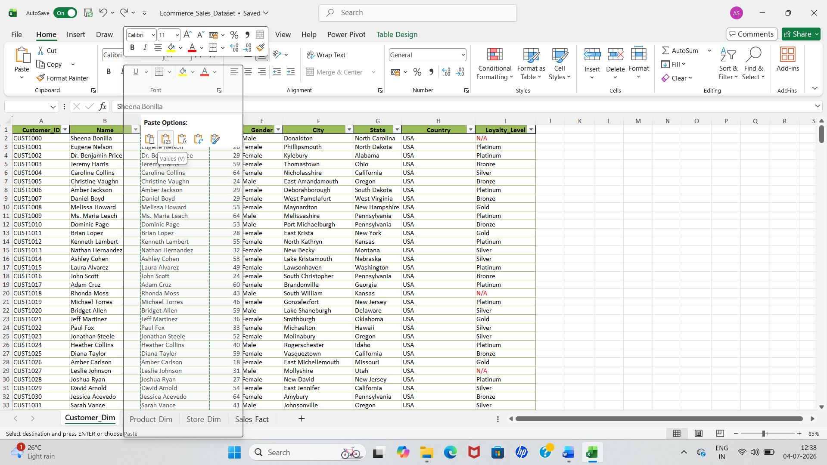
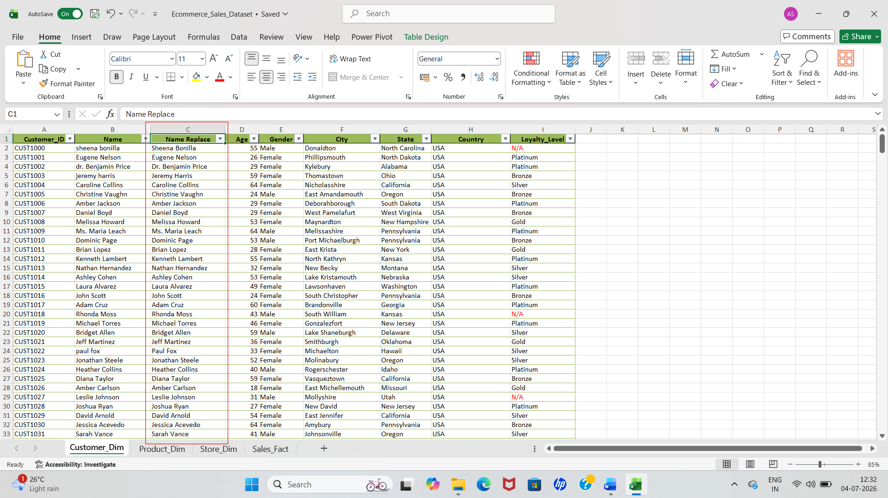
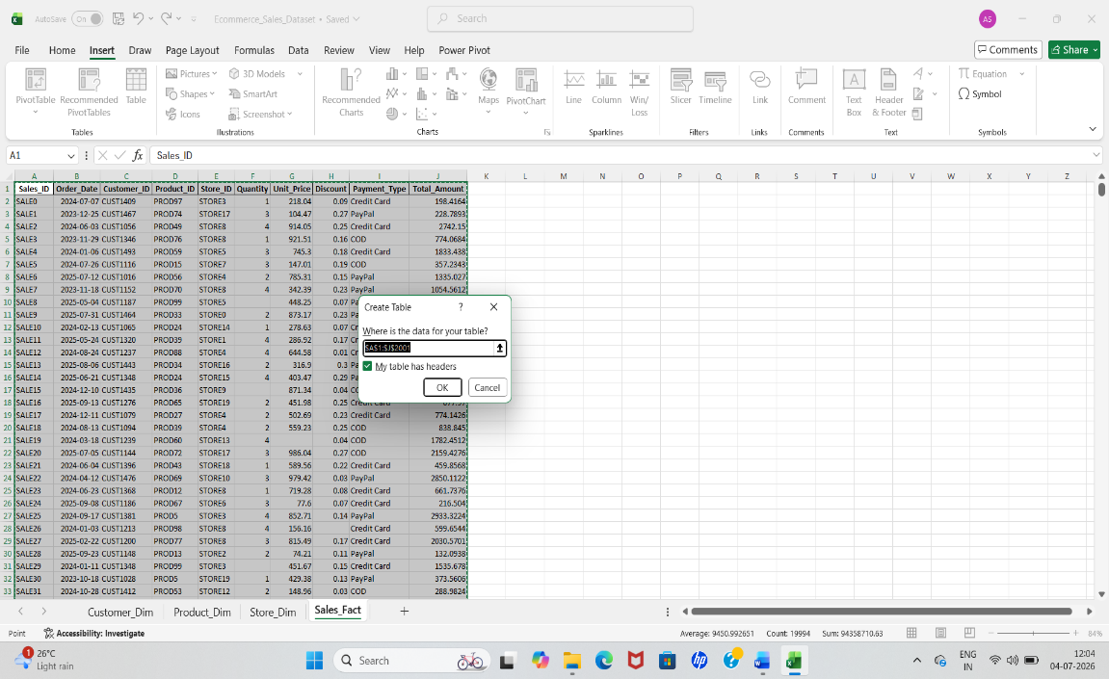

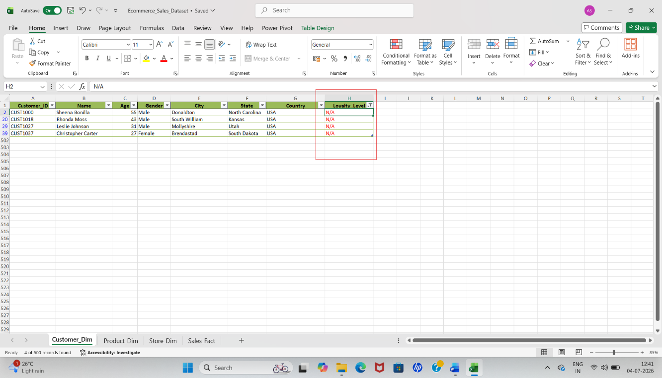

- Checked the Product_Dim sheet for duplicates and confirmed there were none.
- Standardized inconsistencies in the product IDs within the product_dim sheet using Find and Replace.
- ​Calculated the average cost and filled in the missing blank values(cost replace).
- ​Selected all the empty cells in the stock column using the Go To Special feature and filled them with a value of zero.

- Checked the Store_Dim sheet for duplicates and confirmed there were none.
- ​Checked the Sales_Fact sheet for duplicates and confirmed there were none.
- ​Filled the missing quantity values in the Sales Fact sheet using the median.
- ​Filled the missing unit price values using the average.
- ​Filled the missing discount and total amount values using the median.
- ​Highlighted all these filled cells in red color.

- Removed the Sub_Category column because it contained irrelevant data.

- Filled blank quantities, discounts, and total amounts using a single combined equation of IF, ISBLANK, and MEDIAN.
- ​Handled missing unit prices with an equation combining IF, ISBLANK, and AVERAGE.
- ​Combined tables using the VLOOKUP function.
- ​Summed the total amounts using the SUM function.

- Used the descriptive statistics feature within the Data Analysis Toolpak to find the mean, median, standard deviation, and mode for Total Amount and Unit Price.
- ​Created four pivot tables using the 'Sales Fact' main table.
- ​Generated a pivot chart for each of the four pivot tables using the Pivot Chart option within the Pivot Table Analysis tab.
- ​Added the Quantity and Year slicers by clicking on the pivot table, navigating to the PivotTable Analysis tab, and selecting Insert Slicer.
- ​Addressed inconsistencies in the Year slicer by going to the 'Slicer' tab, selecting 'Slicer Settings', and checking the 'Hide items with no data' option.
- ​Created a new worksheet and named it "Dashboard".
- ​Navigated to the View tab and unchecked "Gridlines" to hide them.
- ​Inserted a large rectangle shape from the Shapes menu to serve as the dashboard background.
- ​Placed the four pivot charts and the two slicers inside this rectangle shape.
- Connected the slicers into all the four pivot charts by using, “Report Connection”(checked all the pivot tables)
- ​Created four additional pivot tables on the pivot table sheet for Customer Count, Sum of Total Amount, Sum of Quantity, and Sum of Unit Price.
- ​Linked these values to adjacent cells using the GETPIVOTDATA function.
- ​Added a main heading at the top of the Dashboard using a text box: "E-Commerce Sales Dataset Analysis".
- ​Inserted four rounded rectangle shapes on the dashboard to display the key metrics and placed a smaller rectangle shape inside each rounded rectangle, clicked on the smaller shape, typed an equals sign in the formula bar, selected the linked value using the GETPIVOTDATA function on the pivot table sheet, and pressed enter.
- Then again connect slicer to key metrics, “Report Connection”(checked all the pivot tables).

FINDINGS AND DECISIONS:
1. Data Cleaning and Formatting
​Finding: The original data had many spelling mistakes, double entries (duplicates), and messy formatting in customer names and product details.
​Decision: I removed all duplicate rows and cleaned up the text formatting so that all names and locations look neat and consistent.
​2. Filling Missing Information
​Finding: Some important numbers, like product costs and stock quantities, were completely blank or missing.
​Decision: I used the formulas (like AVERAGE and MEDIAN) to guess and fill in those blank spaces so our calculations would not stop.
3. Sorting and Filtering Data
​Finding: We needed a quick way to find the top-performing products and specific customer groups without searching manually.
​Decision: I applied Excel filters and sorted the data from highest to lowest sales to instantly highlight the best-selling items.
​4. Combining Tables (VLOOKUP)
​Finding: The data was scattered across different sheets and tables (like customer table and product table,store table), making it hard to see everything together.
​Decision: I used the VLOOKUP function to link the tables and bring all the matching information into one main master table.
​5. Grouping Data (Pivot Tables)
​Finding: It was difficult to understand total sales just by looking at thousands of rows of raw data.
​Decision: I created Pivot Tables to automatically group, summarize, and count the data by regions, product categories, and dates.
​6. Final Dashboard and Charts
​Finding: People reviewing the data cannot easily understand text tables during a quick review.
​Decision: I built an interactive dashboard with four different types of charts and two slicers so anyone can click and see sales trends instantly.

